**Q1. Write a program to merge the contents of two given flies into a third file.**

**Code :**

**#include <iostream>**

**#include <fstream>**

**using namespace std;**

**/\***

**Contents of File1.txt:**

**Name : Mavia Khalid**

**Course : MCA**

**Contents of File2.txt:**

**Roll No. : 22MCA026**

**University : Jamia Millia Islamia**

**\*/**

**int main()**

**{**

**ifstream fin;**

**fin.open("File1.txt");**

**string line, merged = "";**

**while (getline(fin, line))**

**{**

**merged = merged + line + '\n';**

**}**

**fin.close();**

**fin.open("File2.txt");**

**while (getline(fin, line))**

**{**

**merged = merged + line + '\n';**

**}**

**fin.close();**

**ofstream fout;**

**fout.open("merged.txt");**

**fout << merged;**

**fout.close();**

**/\***

**Output :**

**Contents of merged.txt:**

**Name : Mavia Khalid**

**Course : MCA**

**Roll No. : 22MCA026**

**University : Jamia Millia Islamia**

**\*/**

**}**

**Q2. Write a function in C++ to count and display the number of lines not starting with alphabet 'A' present in a text file "STORY.TXT".**

**Contents of story.txt:**

**The rose is red.**

**A girl is playing there.**

**Numbers are not allowed in the password.**

**There is a playground.**

**An aeroplane is in the sky.**

**Code :**

**#include <iostream>**

**#include <fstream>**

**using namespace std;**

**int main()**

**{**

**ifstream fin;**

**string line;**

**int count = 0;**

**fin.open("STORY.txt");**

**while (getline(fin, line))**

**{**

**if (line[0] != 'A')**

**count++;**

**}**

**fin.close();**

**cout << "\n\t Lines Not Starting With 'A' in STORY.txt = " << count << endl << endl;**

**return 0;**

**}**

**OUTPUT :**

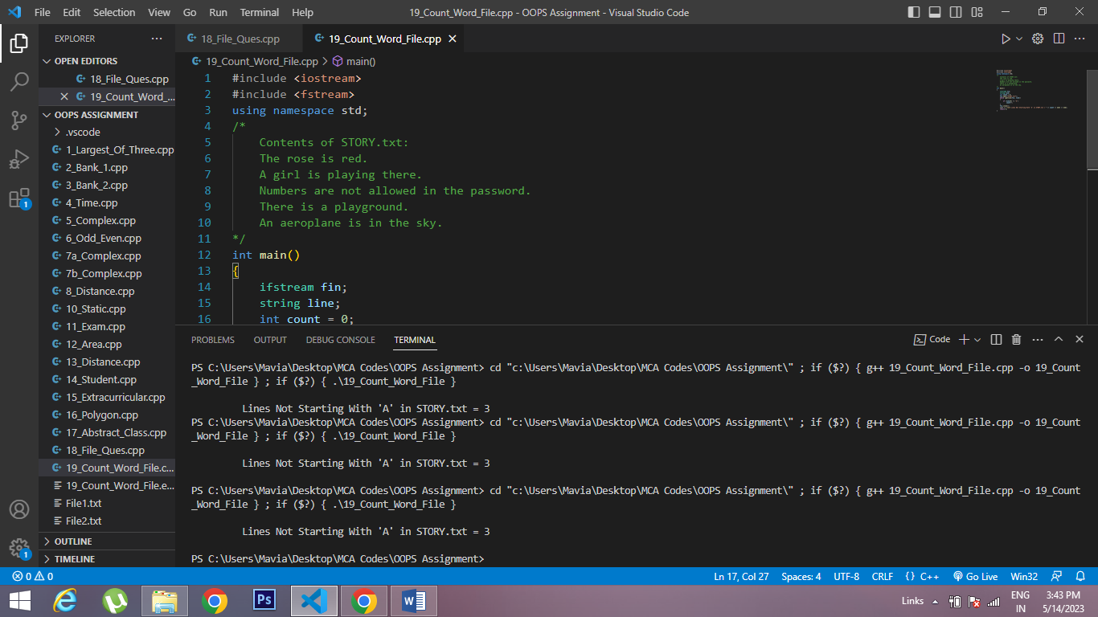

**Q3. Write a program using generic stack class to implement all possible stack operations using pointers.**

**Code :**

**#include<iostream>**

**using namespace std;**

**template<class type>**

**class Stack**

**{**

**type *arr;**

**int top;**

**int size;**

**public:**

**Stack(int size)**

**{**

**this->size = size;**

**arr = new type[size];**

**top = -1;**

**}**

**bool isEmpty()**

**{**

**if(top == -1)**

**{**

**return true;**

**}**

**return false;**

**}**

**int getSize()**

**{**

**return top+1;**

**}**

**type getTop()**

**{**

**if(top > -1)**

**{**

**return *(arr+top);**

**}**

**cout << "\n\t Stack Underflow ";**

**return -1;**

**}**

**void push(type data)**

**{**

**if(top >= size-1)**

**{**

**cout << "\n\t Stack Overflow ";**

**return;**

**}**

**top++;**

**\*(arr+top) = data;**

**}**

**type pop()**

**{**

**if(top == -1)**

**{**

**cout << "\n\t Stack Underflow ";**

**return -1;**

**}**

**type element = *(arr+top);**

**top--;**

**return element;**

**}**

**};**

**int main()**

**{**

**Stack<int> s1(30);**

**Stack<char> s2(30);**

**s1.push(10);**

**s1.push(20);**

**s1.push(30);**

**s1.push(40);**

**s1.push(50);**

**cout << "\n\t Element at Top : " << s1.getTop() << endl;**

**cout << "\t Stack Size : " << s1.getSize() << endl;**

**cout << "\t Popped Element : " << s1.pop() << endl;**

**cout << "\t Popped Element : " << s1.pop() << endl;**

**s2.push('a');**

**s2.push('b');**

**s2.push('c');**

**s2.push('d');**

**cout << "\n\t Element at Top : " << s2.getTop() << endl;**

**cout << "\t Stack Size : " << s2.getSize();**

**for(int i = 0; i < 4; i++)**

**{**

**cout << "\n\t Popped Element : " << s2.pop();**

**}**

**cout << "\n\t Stack Size : " << s2.getSize() << endl;**

**cout << endl;**

**return 0;**

**}**

**OUTPUT :**

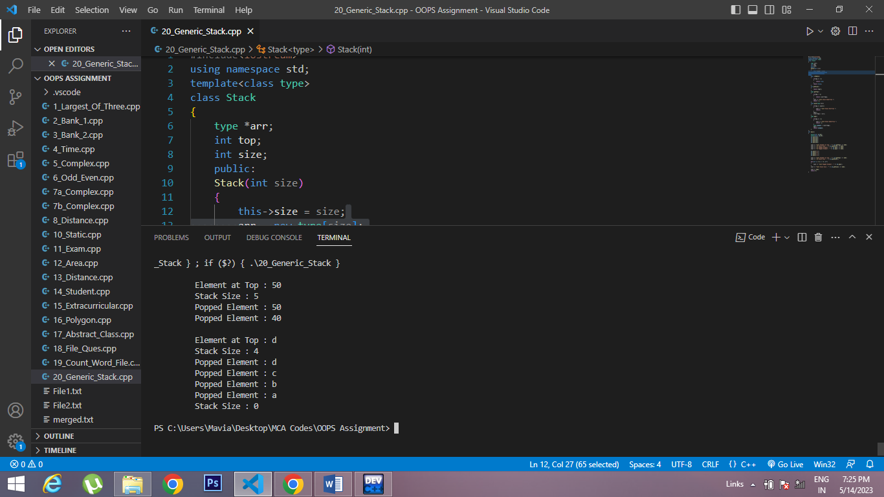

**Q4. Write a program of your choice to handle the occurring exceptions in the program using multiple catch statements.**

**Code :**

**#include <iostream>**

**using namespace std;**

**class error**

**{**

**string exception;**

**public:**

**error(string e)**

**{**

**exception = e;**

**}**

**friend ostream &operator<<(ostream &out, error e)**

**{**

**return out << e.exception;**

**}**

**};**

**template <class type>**

**class Stack**

**{**

**type *arr;**

**int top;**

**int size;**

**public:**

**Stack(int size)**

**{**

**this->size = size;**

**arr = new type[size];**

**top = -1;**

**}**

**bool isEmpty()**

**{**

**if (top == -1)**

**{**

**return true;**

**}**

**return false;**

**}**

**int getSize()**

**{**

**return top + 1;**

**}**

**type getTop()**

**{**

**if (top > -1)**

**{**

**return *(arr + top);**

**}**

**throw(error("\n\t Stack Underflow "));**

**return -1;**

**}**

**void push(type data)**

**{**

**if (top >= size - 1)**

**{**

**throw(error("\n\t Stack Overflow "));**

**return;**

**}**

**top++;**

**\*(arr + top) = data;**

**}**

**type pop()**

**{**

**if (top == -1)**

**{**

**throw(error("\n\t Stack Underflow "));**

**return -1;**

**}**

**type element = *(arr + top);**

**top--;**

**return element;**

**}**

**};**

**int main()**

**{**

**Stack<int> s1(5);**

**Stack<char> s2(30);**

**try**

**{**

**s1.push(10);**

**s1.push(20);**

**s1.push(30);**

**s1.push(40);**

**s1.push(50);**

**s1.push(60);**

**}**

**catch (error &exception)**

**{**

**cout << exception << endl;**

**}**

**cout << "\n\t Element at Top : " << s1.getTop() << endl;**

**cout << "\t Stack Size : " << s1.getSize() << endl;**

**cout << "\t Popped Element : " << s1.pop() << endl;**

**cout << "\t Popped Element : " << s1.pop() << endl;**

**s2.push('a');**

**s2.push('b');**

**s2.push('c');**

**s2.push('d');**

**cout << "\n\t Element at Top : " << s2.getTop() << endl;**

**cout << "\t Stack Size : " << s2.getSize();**

**for (int i = 0; i < 4; i++)**

**{**

**cout << "\n\t Popped Element : " << s2.pop();**

**}**

**try**

**{**

**cout << "\n\t Popped Element : " << s2.pop();**

**}**

**catch(error &exception)**

**{**

**cout << endl << exception << endl;**

**}**

**cout << "\n\t Stack Size : " << s2.getSize() << endl;**

**cout << endl;**

**return 0;**

**}**

**OUTPUT :**

